

UK Leadership Development Programme (P4)

Learning to Lead –
Senior Leadership

2024-2025

Gareth Johnson and our GRJ team

To register, please click here

Dear colleagues

To introduce our 2024/2025 offering, I thought it might be first helpful to answer the question “Who’s Gareth, why this programme and why choose GRJ Education?”

A bit about me & us: I left my job as an Academic Deputy Head in September 2020 in the thick of Covid to launch GRJ Education – with the simple Vision to develop & lead high quality, cost-effective and practical leadership training for school Middle and Senior Leaders. We’ve grown substantially since then – 2023/2024 was a record year in terms of GRJ UK programme attendance, and I’ve been lucky to also explore some other new opportunities which I certainly hadn’t predicted in my initial plan – for example I love now getting stuck into leading specific programmes I write for individual schools and their Heads of Department or leading Away Days for school Senior Leadership Teams. More recently I’ve been gradually introducing all our programmes overseas in partnership with FOBISIA (the Federation of British Schools in Asia), and last May I even found myself leading an international Indian School Heads’ Retreat in Phuket, Thailand – this is something I shall never forget.


Despite our growth these past years, I’m still extremely hands-on with all aspects of everything we do – this was always the intention from the start, it’s always been my way of working and I have no plans for this to change.

It’s a diverse role for sure, and I’m really looking forward to what 2024/2025 brings.

It’s also a pleasure to have developed such a powerful partnership with SCIS (the Scottish Council of Independent Schools) since starting out – I lead the GRJ equivalent of P1 (aspiring to Leadership) and P3 (aspiring to Senior Leadership) for all Scottish schools in the sector, and in 2023/2024 we piloted this P4 as a GRJ/SCIS partnership of sorts – welcoming colleagues from both North and South of the border to join us – it worked really well, hence we are doing it again!

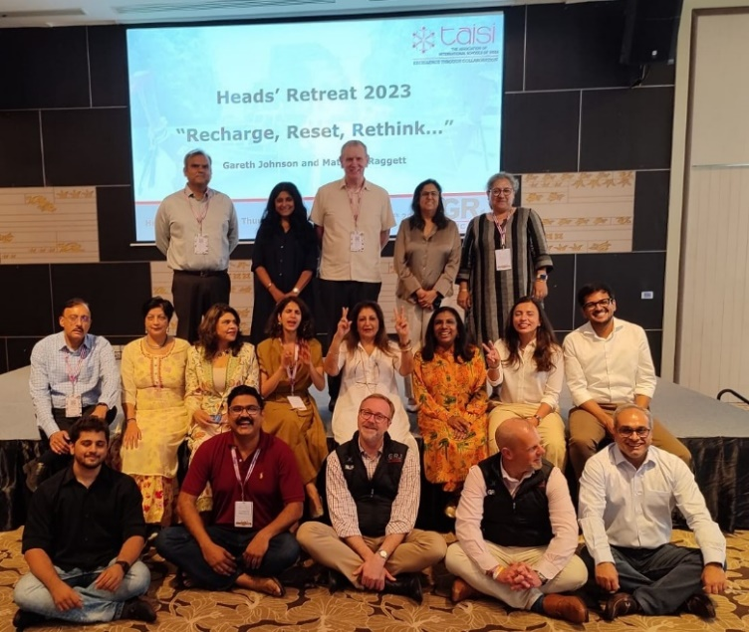
My P4 team comprises Heads, and Senior Leaders representing our independent schools in both England and Scotland – as well as guests from both in and out of our educational world.

Support: This is really key – I love building our positive relationships, which continue well beyond just the formality of our programme work. My team and I are available to offer confidential 1-1 support to any colleague, as they so wish.

“Step-up and lead, don’t sit back and be told how to lead…”: A key pillar of our programmes is self-development – on our other programmes P1 to P3, we invite colleagues to join our team and help lead; here at P4 it is slightly different, so we have designed every aspect of the programme to first test colleagues’ reactions and responses as leaders to the various exercises we have designed, before we share our own team’s experience and the expertise of the various guests we have along.
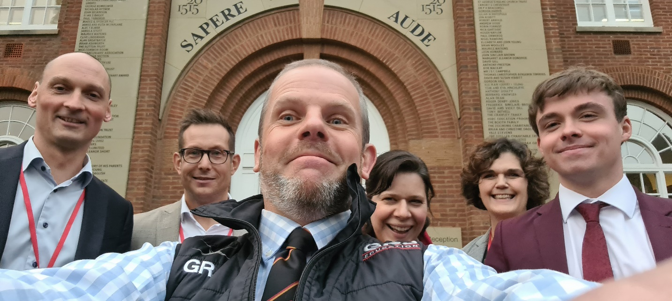

In terms of this programme suitability – when I first started in 2022/2023 we opened it up for all Senior Leaders, but we have found that there is a natural sway towards colleagues brand new or new-ish in post, as well as those seconded to Senior Leadership on a one-term or one-year placement.

I hope you enjoy reading what we’ve got planned,


Everything you need to know – one page headlines, cost, registration

Digital unit 1 (Tuesday October 8th 2024 19.00-21.00)

Whole school leadership – getting it right and not getting it wrong

Digital unit 2 (Tuesday November 12th 2024 19.00-21.00)

The big picture – Values, Vision, Strategy

Digital unit 3 (Thursday January 9th 2025 19.00-21.00)

Dabbling with tough stuff – introduction to UK Employment Law

Digital unit 4 (Tuesday February 11th 2025 19.00-21.00)

Understanding the sums – fathoming whole school finance

Leadership Away Day: Making it all real…

All UK: March 2025 date and school host venue TBC, start 10.00am, finish 16.00

Cost

SCIS member programme cost £360 (VAT included) per colleague.

Appendix one (extra reading): Digital units and Away Day detail

Digital units

Our four digital units take place once per month from October 2024 to February 2025 – units are two hours’ duration hosted via the GRJ Education Zoom platform and each unit is accompanied by a detailed pre-read document and exercise, which colleagues are expected to complete before we meet.

All resources are shared via our GRJ Education secure Padlet, dedicated 100% to this programme. Though unlike our other less senior programmes P1 to P3, we have chosen not to record any of our P4 units – at this level we feel that an appropriate level of sensitivity and confidentiality is to be expected, which has always been well-received.

This coming year we will be piloting an optional team Q&A immediately after each unit for a strict 30 min 21.05-21.30, where colleagues are invited to log back on and ask us anything they would like in confidence.

And like our Away Days, we offer complete flexibility between all our GRJ programmes – so colleagues registered here for P3 are welcome to sit in on our P2 (or maybe even P4) equivalents, if they would like – my advice is to get everything out of this you can…

The March 2025 Leadership Away Day

This is in direct response to feedback from our most recent 2023/2024 cohort – since its launch in September 2022 this programme has been 100% digital, but there was a strong feeling this year – especially due to the close nature of the relationships we formed as a group – that we would like to meet for a face-to-face day at the end of the programme as well. So this is exactly what we are doing, and if all goes to plan we will also be combining the same day with a “Reconnector” day for our 2023/2024 cohort, so that the two groups can mingle, make some solid connections and actually work together in part three of the day.

- Time – I am thinking mid-March to avoid disruption too close to the end of spring term 2025

- Location – likely Newcastle or Edinburgh, dependent on geographical location of the group. I’ve a few host schools in mind and will confirm as soon as we are underway October 2024 and I know who is joining us, from where in the UK.

I am hopeful too that we will run an optional evening social following the day’s work.

Appendix two (extra reading): Programme content

Digital unit 1: Whole school leadership – getting it right and not getting it wrong

An initial opportunity to identify personal Core Values, establish what is most important in whole school leadership, how not to get it wrong – and then agree three “pillars” of excellent Senior leadership for us to refer back throughout the programme. We then finish off by identifying key blockers to successful Senior Leadership with GRJ team tactics to mitigate them.

Digital unit 2: The big picture – Values, Vision, Strategy (VVS)

We invite two guest Heads to join us – one from England and one from Scotland – to share their own school leadership experiences and interpretations of VVS (and it’s a strict timed 5-minute presentation each – always great to observe!) followed by a series of linked breakout exercises covering strategic ownership, delegation and accountability.

Digital unit 3: Dabbling with tough stuff – introduction to UK Employment Law

This is a new unit from 2023/2024 which has proven to be highly effective – we start by unpicking a number of complex employment scenarios using ACAS as a strong reference point; we then round off by asking the GRJ team to share their most complex and challenging recent employment law issue, highlighting the key challenges and how they were overcome.

Digital unit 4: Understanding the sums – fathoming whole school finance

Like unit 3, this is fresh from 2023/2024 based on colleague feedback regarding lack of confidence when it comes to financial acumen. So we address this head-on by inviting one of the UK’s leading school bursars to share concise facts and thoughts followed by the usual related exercises to test understanding & application.

Leadership Away Day: Making it all real…

The day splits nicely into three parts:

Part one – leading crisis management:

We will be joined by our final guest for this programme, who is a retired Detective Superintendent and Head of North Yorkshire & Cleveland Major Incident Teams – and the plan is to run a live exercise which is quite brutal and which unfolds in real time, followed by feedback and takeaways from our guest.

Part two – putting it all together:

An opportunity to undertake some challenging follow-up exercises relating to the trickier elements of our programme covered in units 1-4 – we expect there to be an element of presentation and feedback too, working off the assumption that the GRJ team is acting as a Governing Body of sorts.

Part three – programme reflection:

A chance (at last) to step off the pedal a tiny bit, “glance back” at the key takeaways from the whole programme then “look forward” to the main personal challenges anticipated for academic year 2025/2026, with team suggestions as ever to help support and overcome them. All being well, this is the session which I’d like to invite our 2023/2024 P4 graduates to join us for.

Appendix three: feedback statistics and colleague testimonials

94% of colleagues have rated our most recent UK programmes overall as “excellent” (thankfully the other 6% of responses were “very good”!!!), and 100% of colleagues strongly recommend our programmes to other colleagues.

Here are a few testimonials:

“This is by far the best development course I have ever done…” – Ben Simmons, Deputy Head Academic, Abingdon School, Oxford (promoted from Head of Physics September 2023)

“This programme provides access to experienced Senior Leaders like no other, combined with truly personalised feedback on how you can excel in your current role…” – Rebecca Jones, Assistant Head Teaching & Learning, Charterhouse School, Surrey (promoted from Head of Classics September 2023)

“This is unique in the time you can spend working with peers and school leaders to build up a variety of leadership skills. Highly recommend as a way to not only learn new skills but to also build a supportive professional network that last after the course has finished…” – Kate McGregor, Vice-Principal, Bilingual European School, Milan (promoted from Head of MFL September 2023)

“Fantastic course, with extremely knowledgeable and approachable people leading it. Invaluable advice given continually…” – Dani Mugridge, Director of Sport, Lady Eleanor Holles School, London

“Gareth and the team have been incredibly supportive in imparting knowledge, advice and providing me with the chance to really push myself beyond my comfort zone and step-up…” – Aaron Berry, Head of Science Faculty, Giggleswick School, North Yorkshire

